ADA Accessibility Checklist Table of Contents

Introduction: ADA Accessibility Checklist 1
Parking Area 2
Pathways 5
Accessible Route 5
Entrance 7
Interior Pathways 11

ADA Accessibility Checklist

This accessibility checklist has been provided to assist in identifying key aspects of accessibility for site locations. It is based on the earlier accessibility checklist used for Oklahoma Works office locations and conforms to the latest accessibility guidelines contained in the 2010 ADA Standards for Accessible Design. It has additional information to
help guide individuals utilizing it to accurately assess a given location for compliance with the 2010 Standards.

There is a provision in the 2010 Standards that allows for inchessafe harbor inches protections for facilities that were designed according to, and in compliance with, the earlier 1991 Standards. These safe harbor protections allow a facility that was built or altered in accordance with the 1991 Standards prior to March 15, 2012 to be considered compliant even if the elements in question do not meet the newer Standards.
Therefore, it is necessary to have a complete history of the design of the facility and of the scope and dates of any alterations made to the facility. The safe harbor provisions you will be most concerned with in conducting your survey will likely be about inchesreach ranges inches and bathroom clear floor space measurements.

Reach ranges specify how high, or low, elements need to be in order to be accessible to people using mobility devices. The 2010 ADA Standards require a uniform high end maximum of 48 inches and a low end minimum of 15 inches for any element within a facility that is not obstructed by having to reach across a counter, desk, cabinet or other
Bathrooms 15
Bathroom #1 15
Bathroom #2 22
Bathroom #3 28
Additional Access 34
Water Fountains 34
Public Telephones 35
Fire Alarm Systems 37
Notes 37

object. Examples of elements you will find include dispensers, hand dryers, light switches, etc. on the high end of the range, and electrical outlets, cabinets, shelves, etc. on the low end. The 1991 Standards permitted a high reach maximum of 54 inches for unobstructed elements that can be accessed from the side by an individual in a mobility device.
Likewise, the 1991 Standards allowed a minimum of 9 inches for a side reach. The side reach ranges have been eliminated from the 2010 Standards and now any unobstructed elements must be within the 48
to 15 inch range. The 1991 Standards required 1 Van Accessible space for each 8, or fraction of 8, accessible spaces. The 2010 Standards changed that to 1 for each 6 or fraction thereof.

While elements such as hand dryers and various dispensers will be encountered in bathrooms, the most critical safe harbor provision that will need to be considered is the measurement of clear space required around a toilet. The 2010 ADA Standards specify the requirement of a space, free of any obstructions, measuring 60 inches minimum from the side wall and 56 inches minimum from the back wall, be available at an accessible toilet to facilitate an individual feets ability to transfer to the toilet from a mobility device. The 1991 Standards allowed for a minimum of 48 inches from the side wall at a toilet and also permitted a sink to be placed a minimum of 36 inches from the side wall. The 2010
Standards have eliminated the provision for having a sink installed within the transfer space and now requires the 60 inch minimum measurement from the side wall.

# | Facility: | Location: | Reviewer:

# | Parking | Yes | No # | Images | Comments
1 | Is there ADA Compliant Accessible Parking? |  |  | 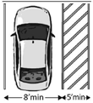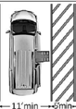 | Note: Van spaces can be 8 feet wide if there is an 8 foot access aisle. This is not preferred because some will  park in this wider access aisle. Parking spaces and access aisles must have no slope greater than 1:48 (2%) in  any direction. Width measurements of parking spaces and access aisles are to centerlines.
2 | Total number of parking spaces available? |  |  | Total # of available spaces = # accessible spaces needed 1 to 25 = 1 accessible  26 to 50 = 2 accessible
3 | Number of accessible parking spaces? |  |  | 51 to 75 = 3 accessible  76 to 100 = 4 accessible  101 to 150 = 5 accessible
4 | Number of van accessible parking spaces? |  |  |  | Note: There must be 1 van accessible space for each 6, or fraction of 6, accessible spaces.
5 | Do the accessible parking spaces have signs marked with the universal symbol indicating accessibility? |  |  | 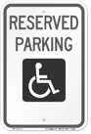 | Note: Signs are required by both the ADA Standards and Oklahoma Statute. Painted symbols on the ground are not compliant markings.

# | Facility: | Location: | Reviewer:

# | Parking | Yes | No # | Images | Comments
6 | Are there signs indicating Van Accessible spaces? |  |  |  | Note: Signs designating van spaces are informative, not restrictive.
7 | Is the bottom of the sign at least 60 inches high? |  |  | 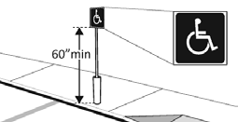
8 | Are accessible parking spaces adjacent to ADA Compliant access aisles? |  |  | 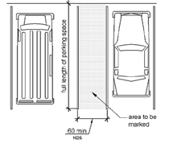 | Note: Two spaces can be served by a single access aisle. Angled van spaces must have the access aisle located  on the passenger side of the vehicle. Changes in level, such as curb ramps, are not allowed in access aisles or parking spaces.

# | Facility: | Location: | Reviewer:

# | Parking | Yes | No # | Images | Comments
9 | Does the access aisle lead to an accessible route to the entrance? |  |  | 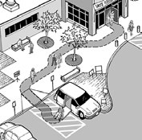 | Note: It is acceptable for the accessible route to pass behind parked cars but it is not preferable.
10 | Is there an accessible route to the entrance from other site arrival points, i.e. bus stops, sidewalks, public streets?

# | Facility: | Location: | Reviewer:

Pathways

There are several different terms that are used in referring to pathways in ADA accessibility. “Accessible route,” “circulation path,” “path of travel,” and “accessible means of egress” are the ones most commonly used. There is also some confusion about exactly what those terms signify. Generally, an Inchaccessible routeInch is the route that an individual with a disability will use to gain entrance to the facility. The Inchcirculation pathInch is where pedestrians move from one place to another and does not necessarily need to be accessible. A Inchpath of travelInch concerns pedestrian passage to altered areas. If an area has been altered it must comply with the ADA Standards for accessiblity and so must the path of travel leading to that area. The requirement to meet
accessibility standards will also incude any restrooms, phones, drinking fountains, etc. along the path of travel. Finally, an Inchaccessible means of egress,Inch as its name implies, refers to a continuous way of travel from within a building that provides an accessible route to an area of refuge or exit, and to the public way.

Any interior hallways serving offices must provide enough maneuvering room for an individual using a mobility device to enter the office. The required amount of space required is determined by whether or not the door swings in or out and whether it has a closer or latch.

# | Accessible Route | Yes | No # | Images | Comments
1 | Is there an accessible route from the accessible parking area to front entrance?
2 | Is the accessible route at least 36 inches wide? |  |  | 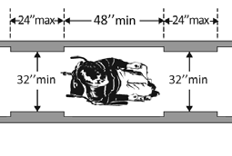 | Note: The accessible route can narrow to no less than 32 inches but only for a maximum distance of 24 inches.  There must also be at least 48 inches of distance between any narrowed sections.

# | Facility: | Location: | Reviewer:
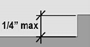
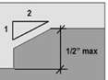
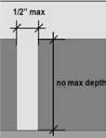
# | Accessible Route | Yes | No # | Images | Comments
3 | Is the accessible route surface smooth?
4 | Is the accessible route surface firm?
5 | Is the accessible route surface slip resistant?
6 | Can a person with a visual disability detect objects protruding into the path with a cane? |  |  | 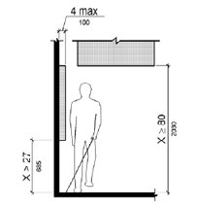 | Note: Objects should be within 27 inches of ground or higher than 80. inches. Any objects within that range can protrude no more than 4 inches. Also, be aware that sloping beams, walls, curved archways, or open stairways can be a protruding object hazard.
7 | Is the accessible route free of obstacles that interfere with accessibility? |  |  |  | Note: Any changes in level greater than 1/4 inch (or 1/2 inch with a 1/4 inch bevel at the top) or horizontal gaps wider than 1/2 inch are not allowed.

# | Facility: | Location: | Reviewer:

# | Entrance | Yes | No # | Images | Comments
1 | If there is more than 1 entrance, is the accessible entrance marked with a sign? |  |  | 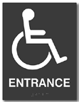
2 | Do non-accessible entrances have signage directing people to accessible entrances? |  |  | 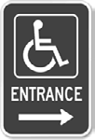
3 | Force required to open door? |  |  |  | Note: There is no specific force requirement for exterior doors. However, if the force required to open exterior doors is so great that it is a barrier to entry for individuals with disabilities, it must be adjusted to a lesser force that will allow entry.

# | Facility: | Location: | Reviewer:

# | Entrance | Yes | No # | Images | Comments
4 | When fully open, does the door have a minimum clear width of at least 32 inches? |  |  | 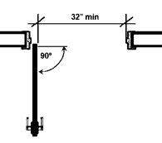 | Note: With the door open at least 90°, measure the distance from the stop to the face of the door.
5 | If the door has a closer, does it take at least 5 seconds to close?
6 | Is there at least 18 inches of clear wall space on the pull side of the door, next to the handle? |  |  | 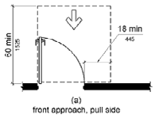 | Note: Doors can only be recessed a maximum of 8 inches. There can be no obstructions greater than 8 inches in the clear wall space anywhere up to the full height of the door (80 inches).
7 | Is door handle no higher than 48 inches? |  |  |  | Note: Any other inchesoperable parts inches i.e. card readers, call buttons, door opener activation buttons, etc. are also required to be no higher than 48 inches.

# | Facility: | Location: | Reviewer:

# | Entrance | Yes | No # | Images | Comments
8 | Can door handle be operated with one hand, with no tight grasping, pinching, or twisting of the wrist? |  |  | 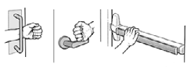 | Note: Door hardware also cannot need more than 5 pounds of force to operate.
9 | Is the carpet pile height of doormats no higher than 1/2 inch? |  |  |  | Note: This 1/2 inch maximum applies to any carpet anywhere within the facility.
10 | Height of threshold? |  |  | 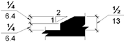 | Note: The height of the threshold cannot be greater than 1/4 inch or 1/2 inch with a 1/4 inch bevel.
11 | Does the door have a level landing 60 inches deep and at least as wide as the door(s) plus required clear wall space on either side of the door? |  |  |  | Note: a level landing can have up to a maximum slope of 1:48 (2%) in any direction.
12 | Does the accessible entrance have a power door opener?
13 | Are there stairs at the main entrance?

# | Facility: | Location: | Reviewer:

# | Entrance | Yes | No # | Images | Comments
14 | If there are stairs, is there a ramp or elevator? |  |  |  | Note: A ramp is any walking surface with a slope greater than 1:20. 5% slope.
15 | Is the slope of the ramp no greater than 1:12? |  |  | 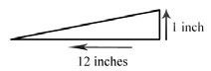 | Note: For each 1 inch of rise--there is 12 inches of ramp length. 8.3% slope.
16 | Is the cross slope of the ramp no greater than 1:48? |  |  | 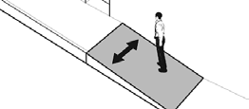 | Note: Maximum 2% slope.
17 | Does the ramp have a non-slip surface?
18 | Do ramps with a rise greater than 6 inches have handrails? |  |  |  | Note: Handrails are required on both sides of the ramp.
19 | Are handrails between 34 inches and 38 inches high?
20 | Is there edge protection on the sides of the ramp? |  |  | 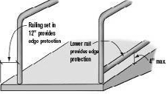 | Note: The placement and design of the railings can provide edge protection or the ramp concrete can be poured with edge protection as part of the design of the ramp.

# | Facility: | Location: | Reviewer:

# | Entrance | Yes | No # | Images | Comments
21 | Is the width between the ramp railings at least 36 inches
22 | Does the ramp have a level landing 60 inches deep and at least as wide as the ramp at both top and bottom? |  |  | 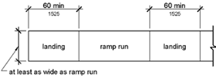 | Note: a level landing can have up to a maximum slope of 1:48 (2%) in any direction.

# | Interior Pathways | Yes | No # | Images | Comments
1 | Is there an accessible circulation path? |  |  | 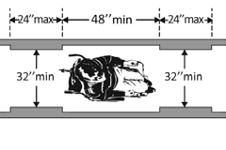 | Note: The accessible path can narrow to no less than 32 inches but only for a maximum distance of 24 inches.  There must also be at least 48 inches of distance between any narrowed sections.
2 | Is there a service counter no more than 36 inches high?
3 | Is there a hallway leading to offices or other spaces?

# | Facility: | Location: | Reviewer:

# | Interior Pathways | Yes | No # | Images | Comments
4 | Wall sconces, fire extinguishers, wall- mounted TV feets, etc. |  |  |  | Note: Objects should be within 27 inches of ground or higher than 80. inches Any objects within that range can protrude no more than 4 inches. Also, be aware that sloping beams, walls, curved archways, or open stairways can be a protruding object hazard.
5 | When fully open, do the office doors have a minimum clear width of at least 32 inches? |  |  | 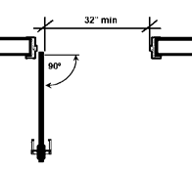 | Note: With the door open at least 90°, measure the distance from the stop to the face of the door. Doors can only be recessed a maximum of 8 inches.

# | Facility: | Location: | Reviewer:

# | Interior Pathways | Yes | No # | Images | Comments
6 | Can the office feets door handles be operated with one hand, with no tight grasping, pinching, or twisting of the wrist? |  |  | 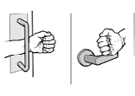
7 | Is the force required to open doors 5 lbs. or less?
8 | Do the office doors open inward (into the office)?
9 | If the doors open inward, is the hallway at least 42 inches wide? |  |  | 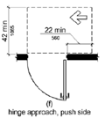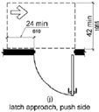 | Note: If the doors are equipped with a closer, the hallway must be at least 48 inches wide with appropriate clear wall space.
10 | If the doors open outward, is the hallway at least 54 inches  wide with clear wall manevering space of at least 42 inches? |  |  | 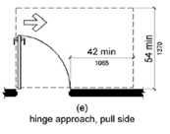 | Note: If the clear wall space is only 36 inches the hallway width must be at least 60 inches

# | Facility: | Location: | Reviewer:

# | Interior Pathways | Yes | No # | Images | Comments
11 | If there is an interior ramp with a rise greater than 6 inches, are there handrails? |  |  | 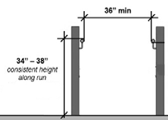 | Note: Minimum 36 inch width between handrails and the gripping surfaces of the handrails minimum 34 inches and maximum 38 inches above the floor on both sides of the ramp.
12 | Can a person with a visual disability detect objects protruding into the path with a cane,  i.e. wall sconces, fire extinguishers, wall- mounted TV feets, etc.? |  |  |  | Note: Objects should be within 27 inches of ground or higher than 80. inches Any objects within that range can protrude no more than 4 inches.  Also, be aware that sloping beams  or walls or curved archways can be a protruding object hazard.

# | Facility: | Location: | Reviewer:

Bathrooms

Bathrooms are often the most difficult to survey for accessibility. There are numerous measurements that need to be taken and in older facilities the bathrooms may have been reconfigured to try to make them more accessible. Determining whether these reconfigured spaces meet all necessary requirements can sometimes be difficult to determine.

Also, consider any safe harbor provisions that might be applicable. When was the facility constructed or last altered? If it was before March 25, 2012, then any dispensers, paper towel, hand soap, hand sanitizer, etc. that an individual in a mobility device can pull up alongside can have a maximum measurement of 54 inches for a side reach. Also, the side transfer space at the accessible toilet can be 48 inches and a sink can be installed a minimum of 36 inches within the space.
Consider protruding object obstructions and maneuvering space at doors. Often, the bathroom was constructed to meet the Standards but when dispensers, hand dryers, trash cans, and other amenities in the bathroom are installed they are placed with no consideration of the Standards. If anything protrudes more than 4 inches, does it
extend at least 27 inches from the floor or is it above 80 inches? If not, an individual using a cane for travel may run into it. If placed next to an inward swinging door, does it extend greater than 8 inches from the wall? If it does an individual in a mobility device will have difficulty opening the door.

# | Bathroom #1 | Yes | No # | Images | Comments
1 | Does the facility indicate they have an accessible bathroom? |  |  | 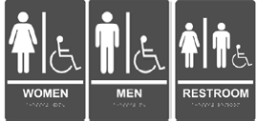 | Note: Either one for each sex or one unisex. Braille is required.
2 | Are there signs at the inaccessible restrooms that give directions to accessible restrooms? |  |  | 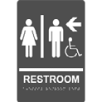

# | Facility: | Location: | Reviewer:

# | Bathroom #1 | Yes | No # | Images | Comments
3 | Do any doors (entrance, toilet stall) swing into the clear floor space required at fixtures? |  |  |  | Note: Clear space at lavatory or urinal  = 30 inches wide by 48 inches deep; clear space at toilet = 60 inches wide by 56 inches deep.
4 | Does the sign include the International symbol for accessibility and is it mounted on latch side of door? |  |  |  | Note: Can also be placed on the push side of the door if there is not enough wall space on latch side.
5 | Is the doorway at least 32 inches clear and have 18 inches clearance on latch  side of door on the pull side? |  |  | 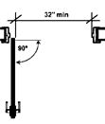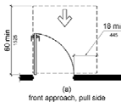
6 | Can the accessible bathroom door handles be operated with one hand, with no tight grasping, pinching, or twisting of the wrist?
7 | Force required to open/close doors? |  |  |  | Note: Must be 5 lbs. or less to open, 5 seconds or more to close if fitted with closer

# | Facility: | Location: | Reviewer:

# | Bathroom #1 | Yes | No # | Images | Comments
8 | Does the entry configuration provide maneuvering space for wheelchair access? |  |  | 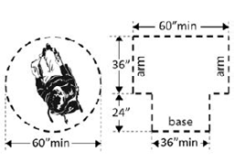 | Note: 36 inches clear width for forward movement and 5 feet diameter space or t-shaped space to make turns
9 | Are the paths in the bathroom at least 36 inches wide?
10 | Does at least one lavatory have clear floor space of 30 inches wide by 48 inches long in front? |  |  | 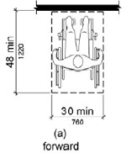

# | Facility: | Location: | Reviewer:

# | Bathroom #1 | Yes | No # | Images | Comments
11 | Is the lavatory rim no higher than 34 inches? |  |  | 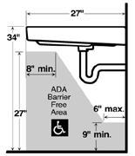
12 | Is there at least 27 inches from floor to bottom of lavatory and at least 8 inches pipe clearance? |  |  | 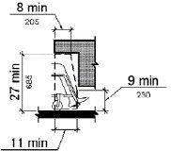
13 | Are the pipes underneath the lavatory wrapped or covered in some way to protect against contact?

# | Facility: | Location: | Reviewer:

# | Bathroom #1 | Yes | No # | Images | Comments
14 | Can the faucet handle be operated with one hand, with no tight grasping, pinching, or twisting of the wrist?
15 | Is there clearance around the toilet measuring 60 inches minimum perpendicular from the side wall and 56 inches minimum  perpendicular from the rear wall for the most accessible stall? |  |  | 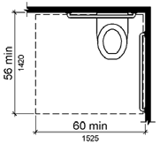 | Note: These are the dimensions required in the most recent version of the Standards, the 2010 ADA Standards. Other configurations may be encountered and may  be acceptable under safe harbor provisions.
16 | Does the centerline of the toilet measure from 16 inches to 18 inches from the side wall? |  |  | 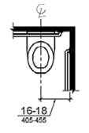

# | Facility: | Location: | Reviewer:

# | Bathroom #1 | Yes | No # | Images | Comments
17 | In the most accessible stall is there a 42 inch minimum long grab bar on the side wall nearest the toilet, installed minimum 33 inches and maximum 36 inches above the floor? |  |  | 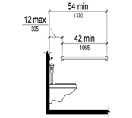 | Note: The grab bar should be installed 12 inches maximum and 54 inchesminimum from the rear wall.
18 | In the most accessible stall is there a 36 inch minimum long grab bar behind the toilet, installed minimum 33 inches and maximum 36 inches above the floor? |  |  | 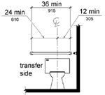 | Note: The grab bar should extend from the centerline of the toilet 12 inches minimum on one side and 24 inchesminimum on the other side.
19 | Are there no dispensers or other fixtures installed within the space 12 inches above and 1 1/2 inches below the grab bars? |  |  |  | Note: Vertical grab bars can be installed within the 12 inches space above the grab bar.

# | Facility: | Location: | Reviewer:

# | Bathroom #1 | Yes | No # | Images | Comments
20 | Is the toilet paper dispenser located 48 inches maximum and 15 inches minimum above the floor and 7 inches to 9 inches in front of the toilet? |  |  | 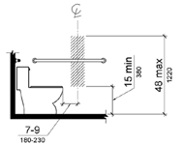 | Note: The body of the dispenser cannot be located in the space 12 inches above and 1 1/2 inches below the grab bar.
21 | In the accessible stall is the toilet seat height between 17 inches  and 19 inches?
22 | Can the accessible stall door handle be operated with one hand, with no tight grasping, pinching, or twisting of the wrist?
23 | Can the toilet flush control be operated with one hand, with no tight grasping, pinching, or twisting of the wrist? |  |  |  | Note: The toilet flush control must be located on the side away from the wall.

# | Facility: | Location: | Reviewer:

# | Bathroom #2 | Yes | No # | Images | Comments
1 | Does the facility indicate they have an accessible bathroom? |  |  | 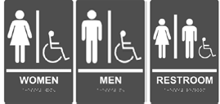 | Note: Either one for each sex or one unisex. Braille is required.
2 | Are there signs at the inaccessible restrooms that give directions to accessible restrooms?
3 | Do any doors (entrance, toilet stall) swing into the clear floor space required at fixtures? |  |  |  | Note: Clear space at lavatory or urinal  = 30 inches wide by 48 inches deep; clear space at toilet = 60 inches wide by 56 inches deep.
4 | Does the sign include the International symbol for accessibility and is it mounted on latch side of door? |  |  |  | Note: Can also be placed on the push side of the door if there is not enough wall space on latch side.

# | Facility: | Location: | Reviewer:

# | Bathroom #2 | Yes | No # | Images | Comments
5 | Is the doorway at least 32 inches clear and have 18 inches clearance on latch  side of door on the pull side?
6 | Can the accessible bathroom door handles be operated with one hand, with no tight grasping, pinching, or twisting of the wrist?
7 | Force required to open/close doors? |  |  |  | Note: Must be 5 lbs. or less to open, 5 seconds or more to close if fitted with closer
8 | Does the entry configuration provide maneuvering space for wheelchair access? |  |  | 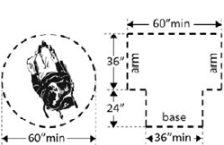 | Note: 36 inches clear width for forward movement and 5 feet diameter space or t-shaped space to make turns

# | Facility: | Location: | Reviewer:

# | Bathroom #2 | Yes | No # | Images | Comments
9 | Are the paths in the bathroom at least 36 inches wide?
10 | Does at least one lavatory have clear floor space of 30 inches wide by 48 inches long in front? |  |  | 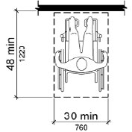
11 | Is the lavatory rim no higher than 34 inches? |  |  | 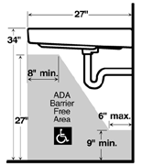

# | Facility: | Location: | Reviewer:

# | Bathroom #2 | Yes | No # | Images | Comments
12 | Is there at least 27 inches from floor to bottom of lavatory and at least 8 inches pipe clearance? |  |  | 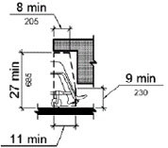
13 | Are the pipes underneath the lavatory wrapped or covered in some way to protect against contact?
14 | Can the faucet handle be operated with one hand, with no tight grasping, pinching, or twisting of the wrist?
15 | Is there clearance around the toilet measuring 60 inches minimum perpendicular from the side wall and 56 inches minimum  perpendicular from the rear wall for the most accessible stall? |  |  |  | Note: These are the dimensions required in the most recent version of the Standards, the 2010 ADA Standards. Other configurations may be encountered and may  be acceptable under safe harbor provisions.

# | Facility: | Location: | Reviewer:

# | Bathroom #2 | Yes | No # | Images | Comments
16 | Does the centerline of the toilet measure from 16 inches to 18 inches from the side wall?
17 | In the most accessible stall is there a 42 inches minimum long grab bar on the side wall nearest the toilet, installed minimum 33 inches and maximum 36 inches above the floor? |  |  | 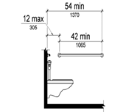 | Note: The grab bar should be installed 12 inches maximum and 54 inches minimum from the rear wall.
18 | In the most accessible stall is there a 36 inches minimum  long grab bar behind the toilet, installed minimum 33 inches  and maximum 36 inches above the floor? |  |  | 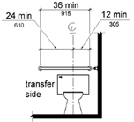 | Note: The grab bar should extend from the centerline of the toilet 12 inches minimum on one side and 24 inches minimum on the other side.

# | Facility: | Location: | Reviewer:

# | Bathroom #2 | Yes | No # | Images | Comments
19 | Are there no dispensers or other fixtures installed within the space 12 inches above and 1 1/2 inches below the grab bars? |  |  |  | Note: Vertical grab bars can be installed within the 12 inches space above the grab bar.
20 | Is the toilet paper dispenser located 48 inches maximum and 15 inches minimum above the floor and 7 inches to 9 inches in front of the toilet? |  |  | 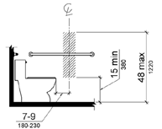 | Note: The body of the dispenser cannot be located in the space 12 inches above and 1 1/2 inches below the grab bar.
21 | In the accessible stall is the toilet seat height between 17 inches  and 19 inches?
22 | Can the accessible stall door handle be operated with one hand, with no tight grasping, pinching, or twisting of the wrist?
23 | Can the toilet flush control be operated with one hand, with no tight grasping, pinching, or twisting of the wrist? |  |  |  | Note: The toilet flush control must be located on the side away from the wall.

# | Facility: | Location: | Reviewer:

# | Bathroom #3 | Yes | No # | Images | Comments
1 | Does the facility indicate they have an accessible bathroom? |  |  | 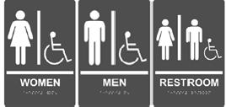 | Note: Either one for each sex or one unisex. Braille is required.
2 | Are there signs at the inaccessible restrooms that give directions to accessible restrooms? |  |  | 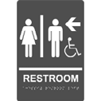
3 | Do any doors (entrance, toilet stall) swing into the clear floor space required at fixtures? |  |  |  | Note: Clear space at lavatory or urinal  = 30 inches wide by 48 inches deep; clear space at toilet = 60 inches wide by 56 inches deep.
4 | Does the sign include the International symbol for accessibility and is it mounted on latch side of door? |  |  |  | Note: Can also be placed on the push side of the door if there is not enough wall space on latch side.

# | Facility: | Location: | Reviewer:

# | Bathroom #3 | Yes | No # | Images | Comments
5 | Is the doorway at least 32 inches clear and have 18 inches clearance on latch  side of door on the pull side?
6 | Can the accessible bathroom door handles be operated with one hand, with no tight grasping, pinching, or twisting of the wrist?
7 | Force required to open/close doors? |  |  |  | Note: Must be 5 lbs. or less to open, 5 seconds or more to close if fitted with closer
8 | Does the entry configuration provide maneuvering space for wheelchair access? |  |  |  | Note: 36 inches clear width for forward movement and 5 feet diameter space or t-shaped space to make turns

# | Facility: | Location: | Reviewer:

# | Bathroom #3 | Yes | No # | Images | Comments
9 | Are the paths in the bathroom at least 36 inches wide?
10 | Does at least one lavatory have clear floor space of 30 inches wide by 48 inches long in front? |  |  | 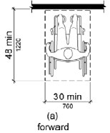
11 | Is the lavatory rim no higher than 34 inches? |  |  | 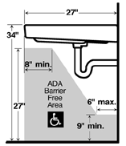

# | Facility: | Location: | Reviewer:

# | Bathroom #3 | Yes | No # | Images | Comments
12 | Is there at least 27 inches from floor to bottom of lavatory and at least 8 inches pipe clearance? |  |  | 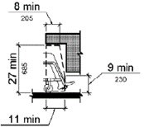
13 | Are the pipes underneath the lavatory wrapped or covered in some way to protect against contact?
14 | Can the faucet handle be operated with one hand, with no tight grasping, pinching, or twisting of the wrist?
15 | Is there clearance around the toilet measuring 60 inches minimum perpendicular from the side wall and 56 inches minimum  perpendicular from the rear wall for the most accessible stall? |  |  |  | Note: These are the dimensions required in the most recent version of the Standards, the 2010 ADA Standards. Other configurations may be encountered and may  be acceptable under safe harbor provisions.

# | Facility: | Location: | Reviewer:

# | Bathroom #3 | Yes | No # | Images | Comments
16 | Does the centerline of the toilet measure from 16 inches to 18 inches from the side wall?
17 | In the most accessible stall is there a 42 inches minimum long grab bar on the side wall nearest the toilet, installed minimum 33 inches and maximum 36 inches above the floor? |  |  | 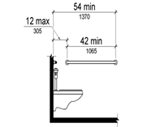 | Note: The grab bar should be installed 12 inches maximum and 54 inches minimum from the rear wall.
18 | In the most accessible stall is there a 36 inches minimum  long grab bar behind the toilet, installed minimum 33 inches  and maximum 36 inches above the floor? |  |  | 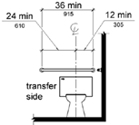 | Note: The grab bar should extend from the centerline of the toilet 12 inches minimum on one side and 24 inches minimum on the other side.

# | Facility: | Location: | Reviewer:

# | Bathroom #3 | Yes | No # | Images | Comments
19 | Are there no dispensers or other fixtures installed within the space 12 inches above and 1 1/2 inches below the grab bars? |  |  |  | Note: Vertical grab bars can be installed within the 12 inches space above the grab bar.
20 | Is the toilet paper dispenser located 48 inches maximum and 15 inches minimum above the floor and 7 inches to 9 inches in front of the toilet? |  |  |  | Note: The body of the dispenser cannot be located in the space 12 inches above and 1 1/2 inches below the grab bar.
21 | In the most accessible stall is toilet seat height between 17 inches and 19 inches?
22 | Can the accessible stall door handle be operated with one hand, with no tight grasping, pinching, or twisting of the wrist?
23 | Can the toilet flush control be operated with one hand, with no tight grasping, pinching, or twisting of the wrist? |  |  |  | Note: The toilet flush control must be located on the side away from the wall.

# | Facility: | Location: | Reviewer:

# | Addl. Access – Water Fountain | Yes | No # | Images | Comments
1 | Does at least 1 drinking fountain have a clear floor space of 30 inches wide x 48 inches long centered in front--for forward reach?
2 | If there is a forward approach, do no less than 17 inches & no greater than 25 inches of clear floor space extend under the fountain?
3 | If fountain is no deeper than 20 inches, are the operable parts no higher than 48 inches above the floor?
4 | If the drinking fountain is between 20 inches and 25 inches deep, are operable parts no higher than 44 inches above floor?
5 | Can the fountain control be operated with one hand, with no tight grasping, pinching or twisting of the wrist?
6 | Is the force to activate the control no more than 5 pounds?

# | Facility: | Location: | Reviewer:

# | Addl. Access – Water Fountain | Yes | No # | Images | Comments
7 | Is the spout: At least 15 inches from rear of drinking fountain? No more than 5 inches from front of drinking fountain?
8 | If more than 1 fountain, is there at least one for standing persons? Spout outlet no lower than 38 inches & no higher than 43 inches above floor?
9 | If bottom edge of fountain is higher than 27 inches above floor, does the front of the fountain protrude no more than 4 inches into circulation path?

# | Addl. Access - Public Telephones | Yes | No # | Images | Comments
1 | Does at least 1 telephone have clear floor space at least 30 inches wide x at least 48 inches long for a parallel or forward approach?

# | Facility: | Location: | Reviewer:

# | Addl. Access - Public Telephones | Yes | No # | Images | Comments
2 | Is the highest operable part of the telephone no higher than 48 inches above the floor?
3 | Is bottom edge of telephone higher than 27 inches above the floor, does the front of the telephone protrude no more than 4 inches into circulation path?
4 | Does at least 1 telephone have a volume control? Is the volume control identified  by a pictogram of a telephone handset with radiating sound waves?
5 | Does at least 1 telephone have a TTY?
6 | Is the touch surface of the TTY keypad at least 34 inches above the floor?
7 | Is TTY identified by the International symbol of TTY?

# | Facility: | Location: | Reviewer:

# | Addl. Access - Public Telephones | Yes | No # | Images | Comments
8 | Do signs that provide directions to public telephones also provide direction to TTY?
9 | Do telephones that do not have a TTY  provide direction to the TTY?

# | Addl. Access –  Fire Alarm Systems | Yes | No # | Images | Comments
1 | If there are fire alarm systems, do they have both flashing lights and audible alerts?

Notes:

