Eligible Training Provider List Program Submissions and Management User Guide:
  - OKJobMatch.com instructions for Oklahoma’s Eligible Training Providers serving the Green Country Workforce Development Board Area.
This guide will demonstrate how training organizations that are on Oklahoma’s Eligible Training Provider (ETP) List may submit and manage training programs in their Eligible Training Provider account on OKJobMatch.com. Once a training provider is approved as an ETP by the state, Oklahoma Works, that provider will be able to submit training programs to be considered for inclusion on the Green Country Workforce Development Board’s (GCWDB’s) ETP List.
The following are actions completed online at OKJobMatch.com and - by whom:
Actions | Action Owner(s)
- Apply to be an approved Eligible Training Provider in the State of Oklahoma.  - Submit programs & request initial approval.  - Update programs and request continued/subsequent approval. | Training Provider
- Serve as a liaison between the State ETP List Administrator and the Training Provider.  - Assist the Training Provider with program management on OKJobMatch.com.  - Review & process Eligible Training Provider applications. | State ETP List Administrator
Review & process initial program submissions; subject to State approval. | - Local, initial determination: Local ETP List Administrator  - State, final determination: State ETP List Administrator
Review & process updated programs for continued/subsequent approval; subject to State approval. | - Local, initial determination: Local ETP List Administrator  - State, final determination: State ETP List Administrator

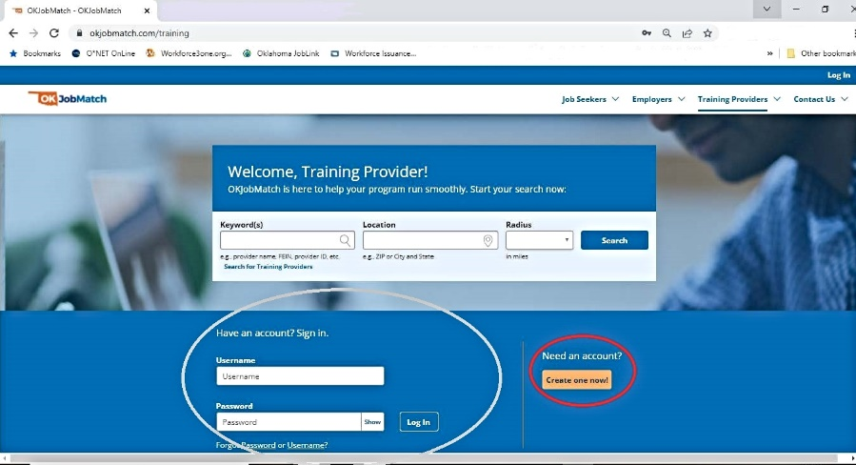
📷 Eligible Training Provider Login Page on OKJobMatch.com – with search, login, & a “Create an Account” button on the bottom of the screen

Stay Current with Online Resources:
Please review and comply with the current State and Local Area ETP List policies and all associated technical assistance and/or lists (e.g., Demand Occupation List) that apply to the management of programs within an OKJobMatch.com ETP account. These items are located on the Green Country Works website Resources > Policy, Research, & Best Practices page under the heading “Eligible Training Provider Resources.”
Updates added to this section of our website will also be communicated via email and/or regular convenings, webinars, and other touchpoints. Updates will be sent/facilitated by the Local ETP List Administrator to the community of Oklahoma’s ETP’s who are potentially or are currently serving the GCWDB Area.

Add a Provider Program

You may add one program when you add a new provider, and it is part of the user registration flow. Once the user account is approved, you can add additional programs. To add additional programs:
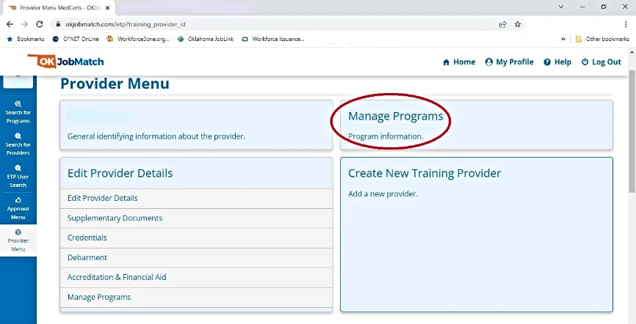
- On the Provider Menu, click Manage Programs. The Provider Programs page displays.
📷 Provider Menu on OKJobMatch.com – with a “Manage Programs” option

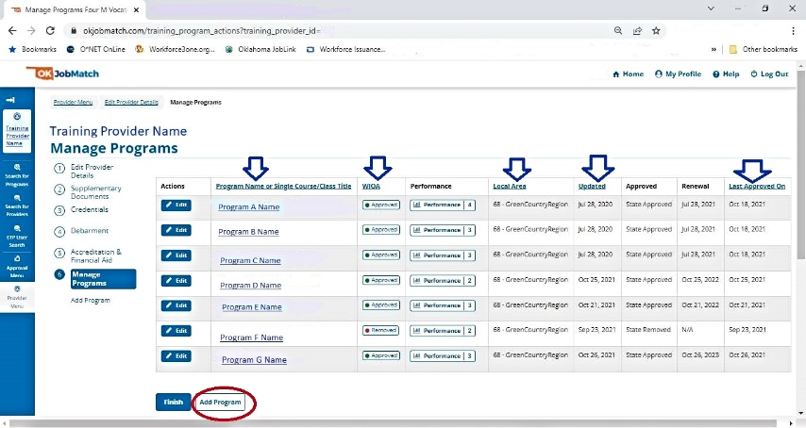
📷 Manage Programs menu on OKJobMatch.com – with an option to ”Add Program” (Note: Columns w/arrows indicated in screenshot are sortable.}

- Click Add Program. The Program Description page displays.

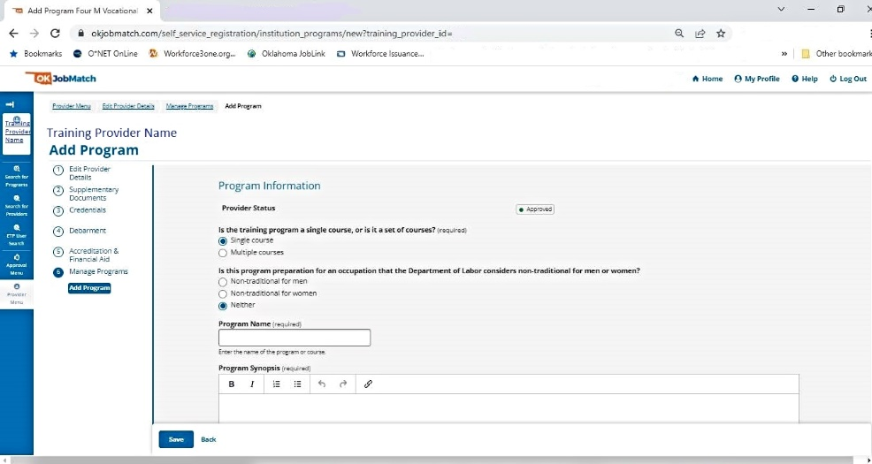
📷 Program Description page on OKJobMatch.com – with fields to complete.

- Complete the fields on the Program Information page (See table for fields and descriptions, below).

📋Table: Field Descriptions for the Program Information screen on OKJobMatch.com:
Program Information
Field | Description
Provider Status | (Display Only) Displays the status of the provider.
Is the training program a single course, or is it a set of courses? (required) | (Option Buttons) Select one:  - Single course  - Multiple courses
Is this program preparation for an occupation that the Department of Labor considers non-traditional for men or women? | (Option Buttons) Select one:  - Non-traditional for men  - Non-traditionalfor women  - Neither  According to the U.S. Department of Labor, a nontraditional occupation is one in which 25 percent or less of one gender is employed.
Program Name (required) | (Text) Enter the name of the program or course.
Program Synopsis (required) | (Text) Enter a brief description of the program.
Method of Delivery (required) | (Option Buttons) Select one:  - Online, e-learning, or distance learning  - In Person  - Hybrid or blended
Training Schedule (required) | (Check Boxes) Select all that apply:  - Daytime hours  - Evening hours  - Weekends  - Other
Curriculum Competency Based | (Text) If the curriculum is competency-based, describe the competencies.
Prerequisite (required) | (Option Buttons) Select one:  - No prerequisites  - High school diploma  - Associate’s degree  - Bachelor’s degree  - Courses only  - Education and Courses
Total Credit/Curriculum Hours (required) | (Text) Enter the number of credit or curriculum hours.
Total Number of Training Weeks | (Text) Enter the number of weeks needed to complete the program / course.
Apprenticeship sponsors using this program | (Drop-down menu) Select the Registered Apprenticeship Sponsor using this program. (Select multiple entries from the list by holding down the Ctrl Key and clicking multiple selections.)
Training Location | (Text) Enter the street address of the training location.
ZIP (required) | (Text) Enter the ZIP code where the training is located.
County (required) | (Drop-down) Select [one] the county where the training is located.
Website | (Text) Enter link to provider/program website.
Program Length | (Drop-down) Select the program length that applies:  - Quarter  - Semester  - Trimester  - Other  The program length indicates the type of periods for the training (i.e., if the training is offered by the semester, but takes two semesters to complete, select Semester). The total length of the training is indicated by Total Credit/Curriculum Hours and/or Total Number of Training Weeks.
Type of Credential (required) | (Check boxes) Select all the resulting credential(s) achieved by completing the program:  - Industry certification  - Apprenticeship certification  - Government license  - Associate’s degree  - Bachelor’s degree and above  - Community college certification  - Secondary school diploma  - Employment  - Measurable skills gain  - Other
Name of Credential (required) [Please note that this is a requirement even if it is not marked as such with an “*” online.] | (Text) Enter the exact name(s) of the credential(s) received when the course is completed. [This allows for the entry of a large number of characters, but if additional room is needed, please add any missing information to the program synopsis.]
Type of Financial Aid Offered (required) | (Text) Enter the type of financial aid for which this program is eligible.
Refund Policy | (Text) Enter a description of the provider’s refund policy for this program.
Program Cost Items (required: all applicable costs)
In-State/District Tuition | (Text) Enter the cost.
[Description] | (Text) Enter a description of the cost. If district, name the district.
Out-of-State/District Tuition | (Text) Enter the cost.
[Description] | (Text) Enter a description of the cost. If district, name the district.
Registration Fee | (Text) Enter the cost.
[Description] | (Text) Enter a description of the cost. If the fee is due for each semester and the program is more than one semester, describe.
Books (Estimated) | (Text) Enter the cost.
[Description] | (Text) Enter a description of the cost. If the cost for books is for one semester, and the program is more than one semester, describe.
Supplies/Materials/Hand Tools (Not Included in Tuition) | (Text) Enter the cost.
[Description] | (Text) Enter a description of the cost. List the supplies, materials, and hand tools required and the student’s estimated cost. If the cost is for one semester, and the program is more than one semester, describe. Include all costs: art supplies for art classes, fuel charges for truck driving, etc.
Testing/Exam Fees | (Text) Enter the cost.
[Description] | (Text) Enter a description of the cost. Indicate when the testing fees are due: before or after the training, and to whom they are paid. For example, network administrator certification exams are administered by a third party and the student is required to pay the third party to take the exam.
Graduation Fees | (Text) Enter the cost.
[Description] | (Text) Enter a description of the cost, for example, a diploma fee.
Other Fees | (Text) Enter the cost.
[Description] | (Text) Enter a description of the cost. List and describe any other costs. If the cost for books is for one semester, and the program is more than one semester, describe.
In-State Total Cost | (Text) Enter the total in-state cost.
Out-Of-State Total Cost | (Text) Enter the total out-of-state cost.
Curriculum
Certified | (Toggle Switch) Select Yes or No. If the curriculum is certified by an accrediting entity or national standardization program, select Yes. If it is not, select No.
Authorizing Entity | (Text) Is the proposed curriculum currently certified by an accrediting agency or similar national standardization program? If yes, enter the name of the agency or authorizing entity.
Occupations (required: at least 1 SOC)
[Program Type] Title | (Display Only) displays the Classification of Instructional Programs (CIP) title after the CIP is selected.
Program Type | (Text) Click CIP Lookup to search for and select the Classification of Instructional Programs. The CIP should be provided by the training provider.
[Occupation Title (O*Net-SOC)] Title | (Display Only) Displays the O*NET title after the O*NET is selected.
Occupation Title (O*Net-SOC) | (Text) Click ONET Lookup to search for and select an occupation for which this program prepares the student.
Hourly Wage 1 | (Text) Enter the hourly wage for an entry-level employee in this occupation.
Required Certification 1 | (Text) Enter a description of any certifications required to enter employment in this occupation.
[Occupation Title (O*Net-SOC)] Title | (Display Only) Displays the O*NET title after the O*NET is selected.
Occupation Title (O*Net-SOC) | (Text) Click ONET Lookup to search for and select an occupation for which this program prepares the student.
Hourly Wage 2 | (Text) Enter the hourly wage for an entry-level employee in this occupation.
Required Certification 2 | (Text) Enter a description of any certifications required to enter employment in this occupation.
[Occupation Title (O*Net-SOC) Title | (Display Only) Displays the O*NET title after the O*NET is selected.
Occupation Title (O*Net-SOC) | (Text) Click ONET Lookup to search for and select an occupation for which this program prepares the student.
Hourly Wage 3 | (Text) Enter the hourly wage for an entry-level employee in this occupation.
Required Certification 3 | (Text) Enter a description of any certifications required to enter employment in this occupation.

- Enter 1-3 O*Net SOC (Standard Occupational Classification) Code(s) for which the program is most closely related.

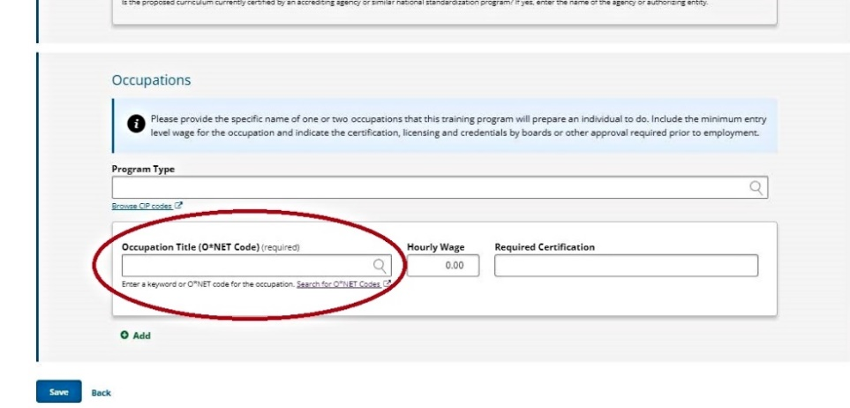
📷 Program Description page on OKJobMatch.com – bottom of the screen with option to search for and/or enter an SOC code.

📷 The following screenshots show an example of searching for and entering SOC Codes for programs.
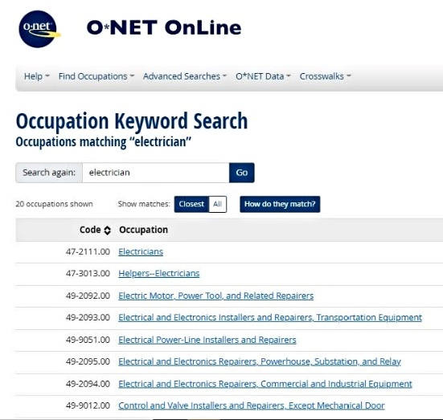
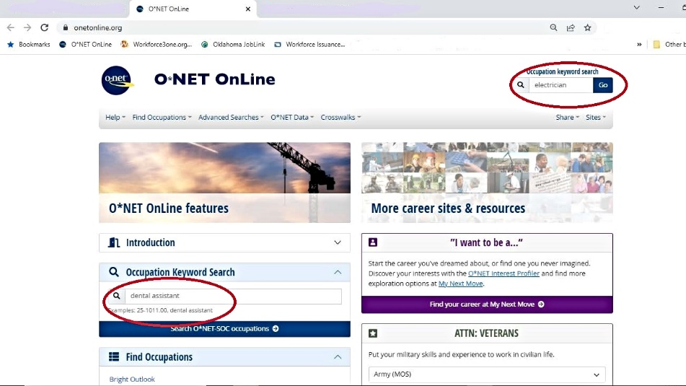
- Search https://www.onetonline.org/ for, as an example the SOC Code and top related SOC Codes for Electricians.
- Verify SOC Code is on the GCWDB Approved Demand Occupation List. 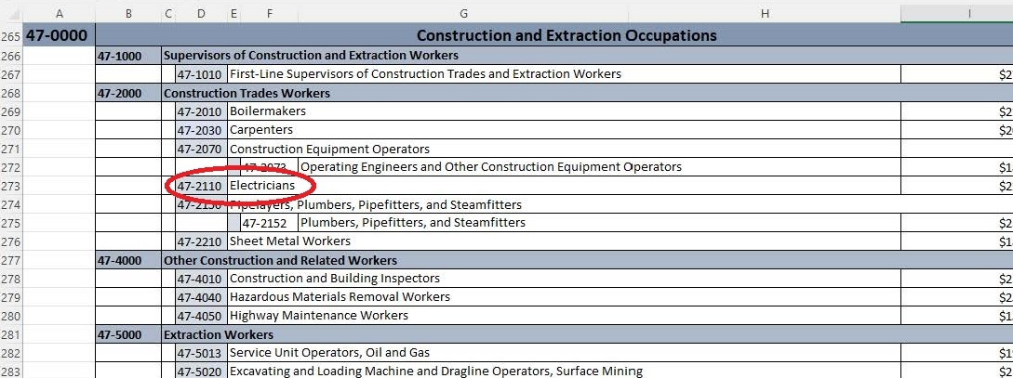
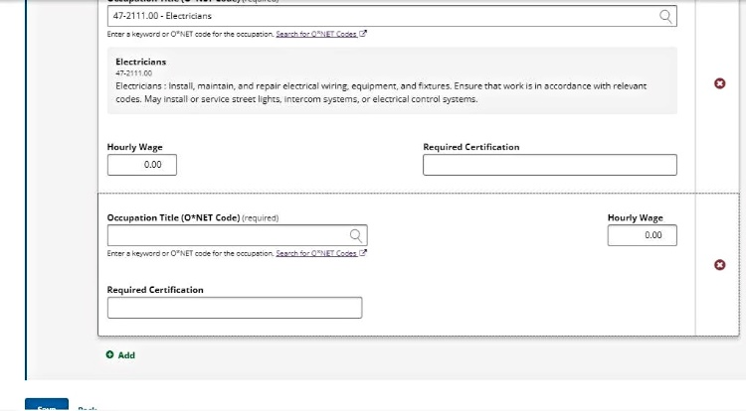
- Enter SOC Code for Electrician & Click +Add to enter up to two more related SOC codes, as appropriate, and click Add.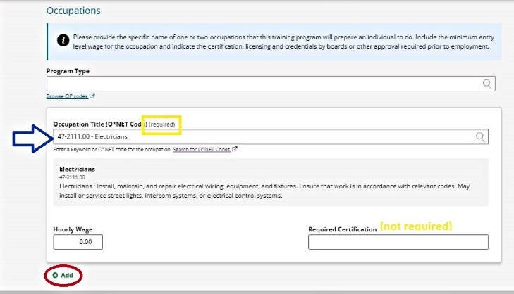

ADD PROGRAM PERFORMANCE

If the program has already been administered, go to the Program Performance page and complete the Program Performance for Overall (aka All Students) using raw numbers (See table for fields and descriptions).
- Any program that is covered by Higher Education Act (HEA) or is a registered apprenticeship program is not required to complete the Program Performance page for initial eligibility; however, it is encouraged. All programs must complete the Program Performance page to be considered for renewal (subsequent eligibility). If you do not wish to complete the Program Performance page at this time, click Save on the Program Description page.
- From the Manage Programs screen, click on the edit button next to the program you are updating. From the Edit Program Screen menu, click Performance.
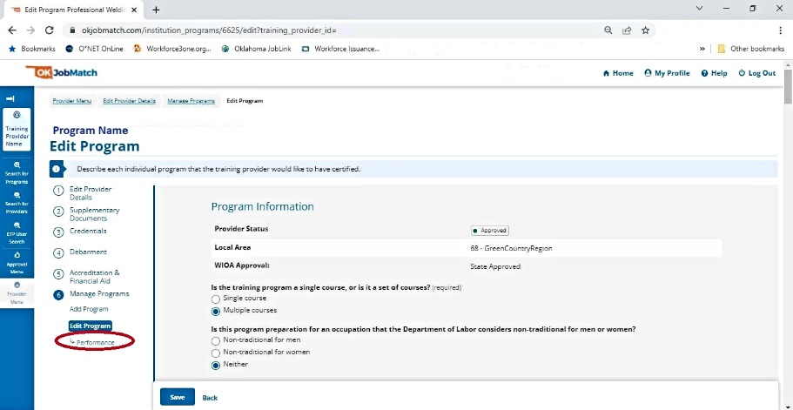
📷 Edit Program menu on OKJobMatch.com – with a “Performance” option with link.

- In the Performance Screen, click Add Performance. The Add Program Performance page displays.
- If you are no longer on the Program Description page, click Programs on the Provider Menu, then click Edit beside the program to which you are adding Program Performance information. The Program Description page displays. Follow the directions, beginning with Step 1.
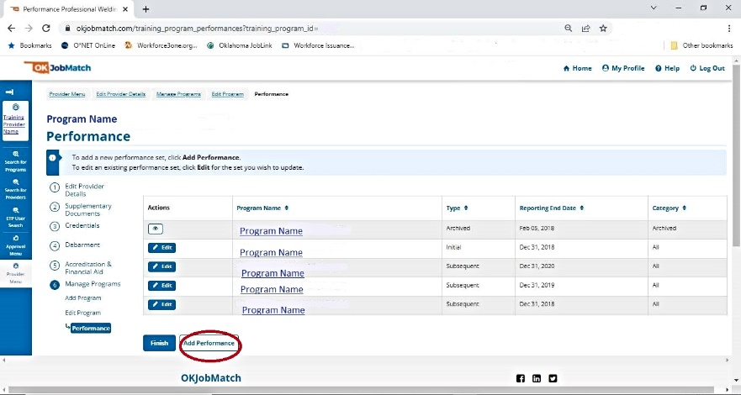
📷 Performance Screen on OKJobMatch.com – with an “Add Performance” option.

- Complete the fields on the Program Performance page and click Add. (See table for fields and descriptions).
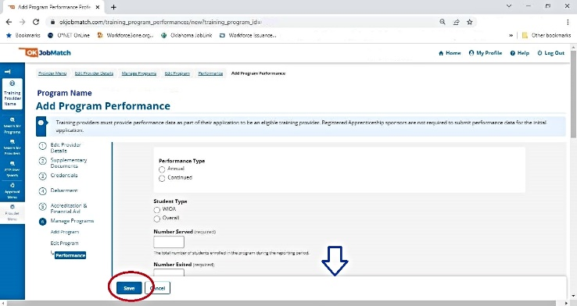
📷 Program Performance page on OKJobMatch.com – with fields to complete and Add button.

📋Table: Field Descriptions for the Program Performance screen on OKJobMatch.com:
Program Performance
Field | Description
Performance Type? (required) | (Option Buttons) Select one:  - Annual – Select this only if this is the initial request for program approval. Enter the most recent performance information for the program that covers a one-year period.  - Continued – Select this for any request for subsequent/continued program approval. Enter the most recent performance information for the program that covers a one-year period.
Student Type (required) | (Option Buttons) Select “Overall”:  - WIOA (Do Not Select; This is for ETP List Administrator use only.)  - Overall (Always selected by a Training Provider.)
Begin Date  (required) | (Text or Calendar Select) Enter the program performance begin date in Mmm DD,YYYY format (ex. Jul 1, 2021)
End Date (required) | (Text or Calendar Select) Enter the program performance end date to conclude a one-year period in Mmm DD,YYYY format (ex. Jun 30, 2021)  *Performance data is required to reflect a one-year period as such: July 1, 2020 – June 30, 2021, or January 1, 2021 – December 31, 2021. Others may report based on the Federal reporting year, October 1, 2020 – September 30, 2021. The requirement is that you provide the most up to date data you have available.
Number Served (required) | (Text) Enter the number of students enrolled in the program during the reporting period.
Number Exited (required) | (Text) The total number of students who completed, withdrew, or transferred from the program during the reporting period.
Number Completed (required) | (Text) The total number of students who successfully completed the program during the program year (did not withdraw or transfer).
Number Employed in 2nd Quarter After Exit (required) | (Text) Enter the number of students who were employed in the 2nd quarter after leaving the program.
Number Employed in 4th Quarter After Exit (required) | (Text) Enter the number of students who were employed in the 4th quarter after leaving the program.
Number Who Attained Credentials (required) | (Text) Enter the number of students who earned credentials upon completion of the program.
Median Earnings in 2nd Quarter After Exit (Required) | (Text) Enter the median quarterly* wage students earned in the 2nd quarter after leaving the program.
Average Earnings 2nd Quarter After Exit (Required) | (Text) Enter the average quarterly* wage students earned in the 2nd quarter after leaving the program.
Average Earnings 4th Quarter After Exit (required) | (Text) Enter the average quarterly* wage students earned in the 4th quarter after leaving the program.

